|  | | |
| --- | --- | --- |

## **Introduction**

### Computers are composed of various hardware components that work together to execute tasks efficiently. These components include the Central Processing Unit (CPU), memory, storage devices, and more. This document provides a brief overview of the fundamental hardware components of a computer system.

### **1. Central Processing Unit (CPU)**

The CPU is the brain of the computer. It processes instructions, performs calculations, and manages the flow of data within the system. Modern CPUs come with multiple cores to enhance performance. A CPU executes instructions from programs through the fetch-decode-execute cycle, ensuring the system runs smoothly. The speed of a CPU is measured in gigahertz (GHz), and newer models feature advanced architectures, higher clock speeds, and better energy efficiency. CPUs also incorporate cache memory to speed up operations and optimize data processing. Thermal management is essential to prevent overheating, which is why cooling solutions like fans and liquid coolers are commonly used.

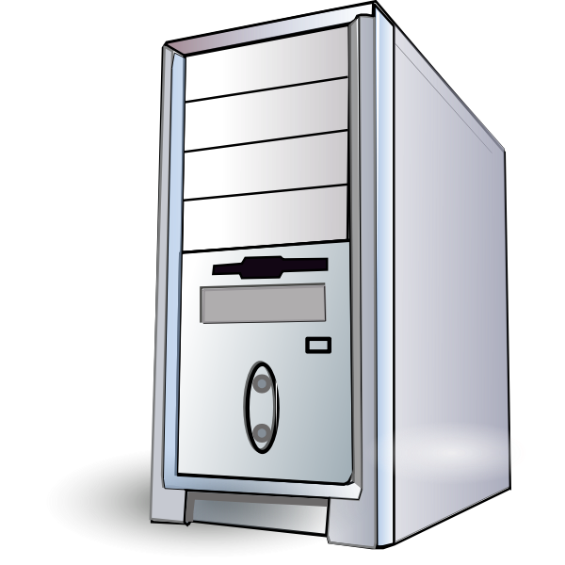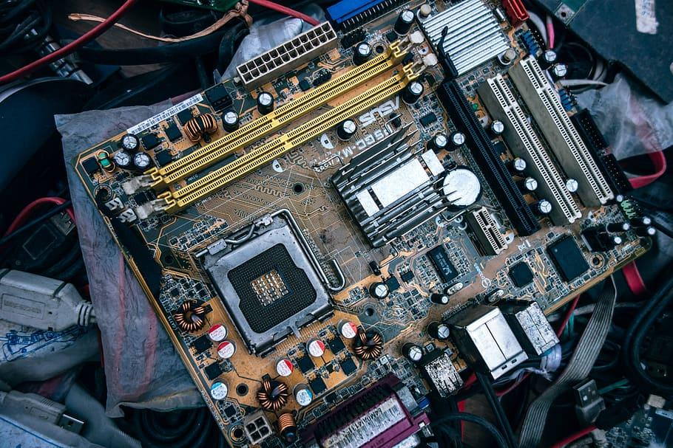

### **2. Random Access Memory (RAM)**

RAM is temporary memory that stores data for quick access by the CPU. It significantly affects system speed and multitasking capabilities. More RAM allows for smoother performance in applications and games. RAM comes in various types, including DDR3, DDR4, and DDR5, each offering improvements in speed and efficiency. The capacity of RAM

is measured in gigabytes (GB), with higher amounts enabling the system to handle more tasks simultaneously. RAM also plays a crucial role in gaming and content creation, as high-performance applications require fast data access. Additionally, dual-channel and quad-channel memory configurations improve data transfer rates, enhancing overall system efficiency.

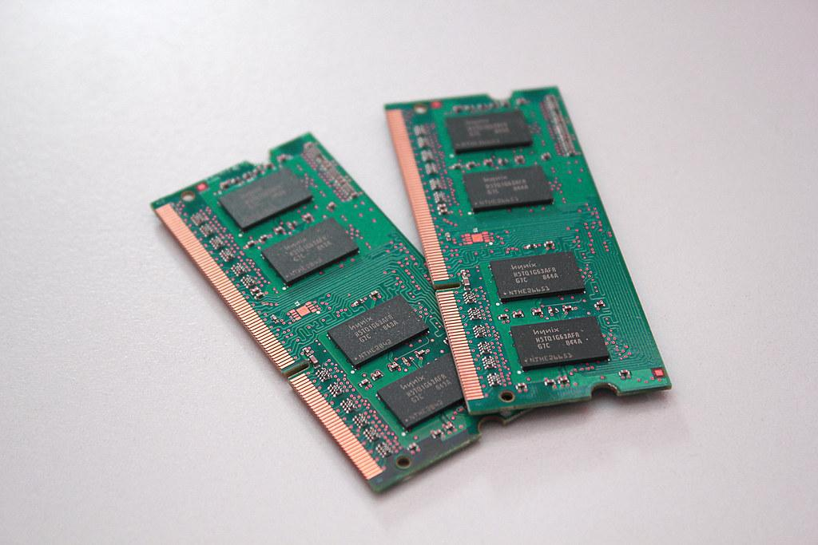

### **3. Hard Disk Drive (HDD)**

HDDs provide long-term storage for data. They use spinning magnetic disks to read and write data. While slower than SSDs, HDDs offer large storage capacities at a lower cost. The rotational speed of HDDs, measured in RPM (Revolutions Per Minute), affects their performance. Common speeds include 5400 RPM and 7200 RPM, with higher speeds delivering faster data access. HDDs use SATA connections and come in various capacities, ranging from hundreds of gigabytes to several terabytes. Despite their declining use in favor of SSDs, HDDs remain a viable option for mass storage, especially for backups and archival purposes.

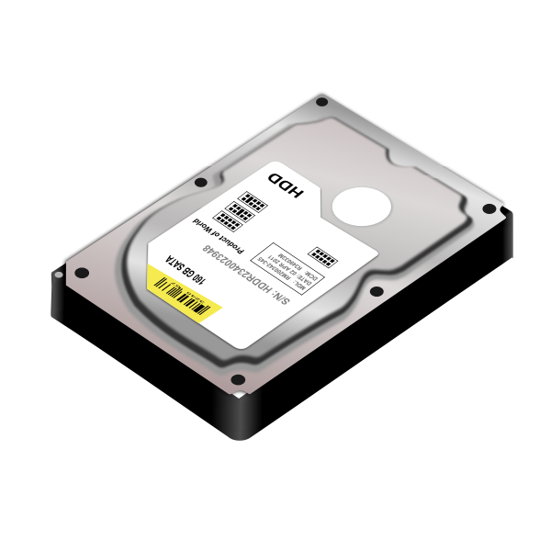

**4. Solid State Drive (SSD)**

SSDs are faster alternatives to HDDs, using flash memory for data storage. They improve system boot times, application loading speeds, and overall responsiveness. Unlike HDDs, SSDs have no moving parts, which enhances their durability and reliability. They come in different form factors, such as 2.5-inch SATA, M.2, and PCIe NVMe, with varying speed capabilities. NVMe SSDs offer the highest speeds, making them ideal for gaming and professional workloads. SSDs also consume less power than HDDs, making them suitable for laptops. Over time, SSD prices have decreased, making them a popular choice for primary storage solutions.

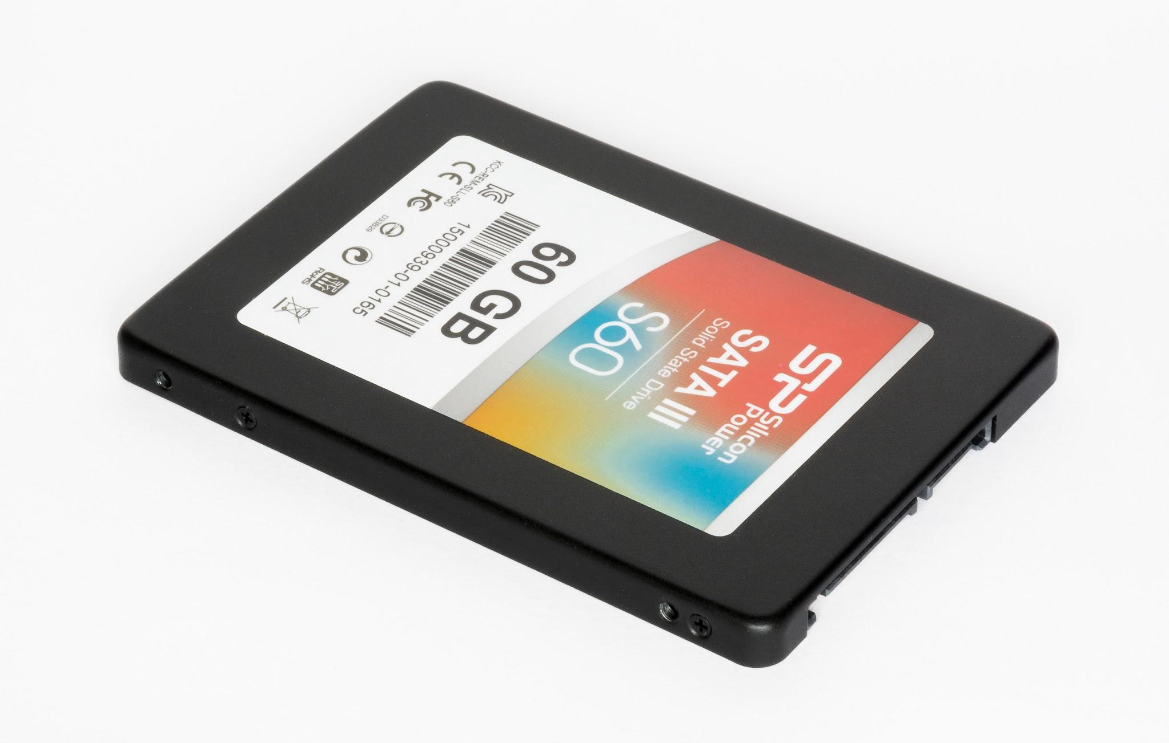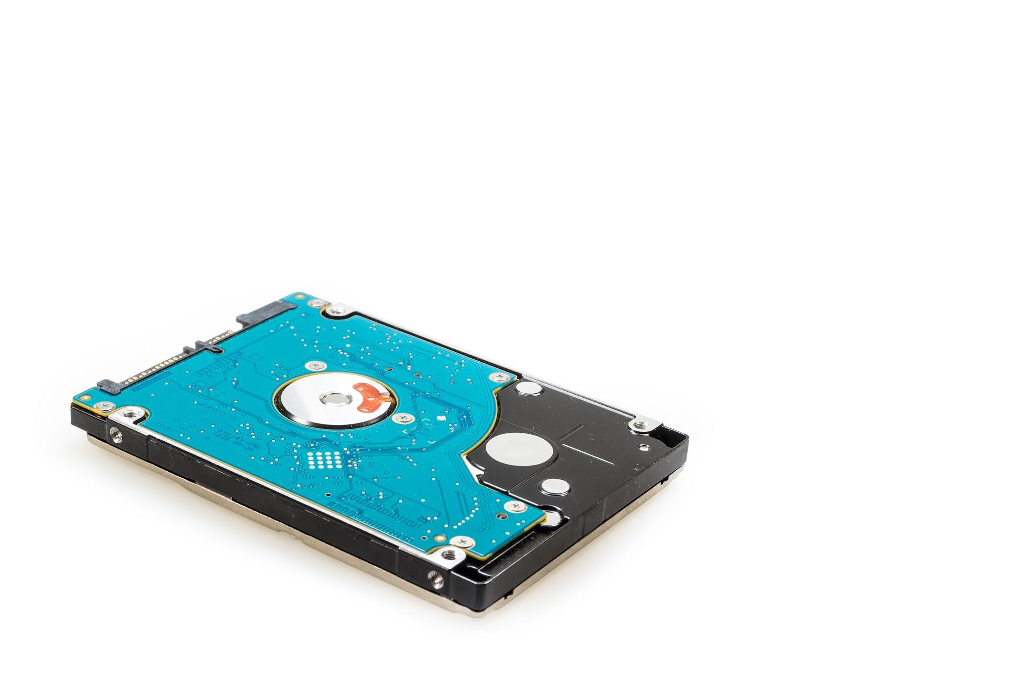

### **5. Motherboard**

The motherboard is the main circuit board that connects all components. It houses the CPU, RAM, storage devices, and expansion cards, providing communication between them. Motherboards come in different form factors, including ATX, Micro-ATX, and Mini-ITX, offering various levels of expandability. They include multiple connectivity options such as USB ports, audio jacks, and networking interfaces. High-end motherboards feature advanced cooling solutions, built-in Wi-Fi, and overclocking capabilities. The chipset determines compatibility with processors and memory types. Choosing the right motherboard ensures system stability and upgrade potential, making it a crucial component in computer assembly.

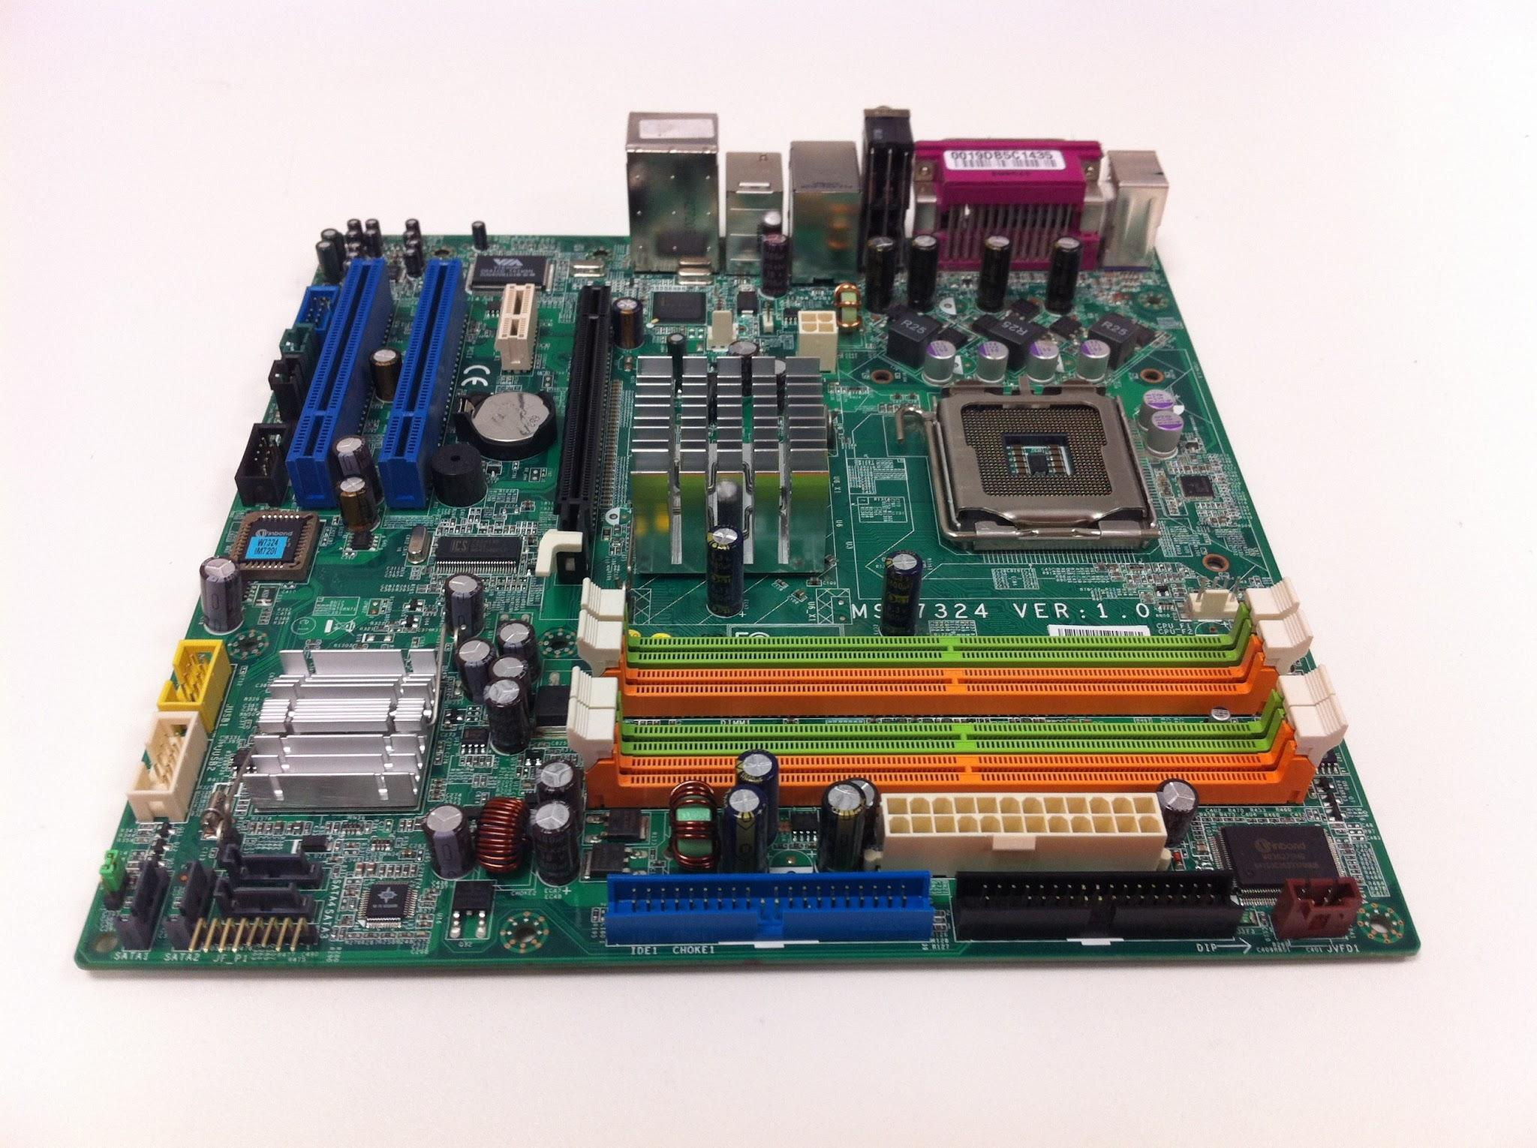

### **6. Power Supply Unit (PSU)**

The PSU converts electricity from an outlet into a usable form for the computer. It provides power to all internal components and ensures stable operation. PSUs come in different wattages to accommodate various system configurations, with modular and non-modular designs. Modular PSUs allow users to connect only the necessary cables, improving cable management and airflow. Efficiency ratings such as 80 Plus Bronze, Silver, Gold, and Platinum indicate energy efficiency. A reliable PSU protects components from voltage fluctuations and power surges, ensuring the system runs smoothly without sudden shutdowns or damage.

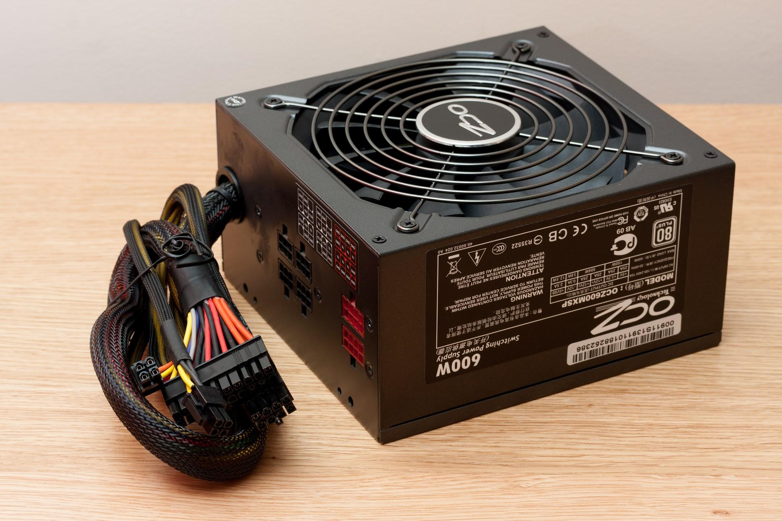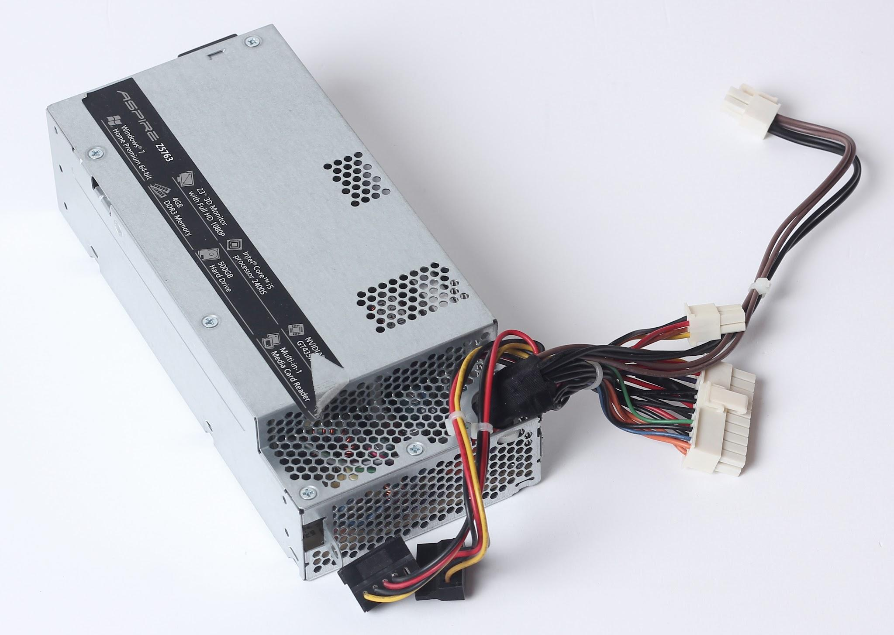

### **7. Graphics Processing Unit (GPU)**

GPUs render images, videos, and animations. Dedicated GPUs are essential for gaming, video editing, and 3D rendering, while integrated GPUs handle basic tasks. Modern GPUs feature dedicated VRAM, which enhances graphics performance. High-performance GPUs are crucial for gaming at high resolutions and refresh rates. GPUs also play a vital role in AI processing, machine learning, and cryptocurrency mining. They connect to motherboards via PCIe slots, with advanced models requiring additional power connectors. Cooling solutions, such as fans and liquid cooling, help maintain optimal temperatures during intense workloads.

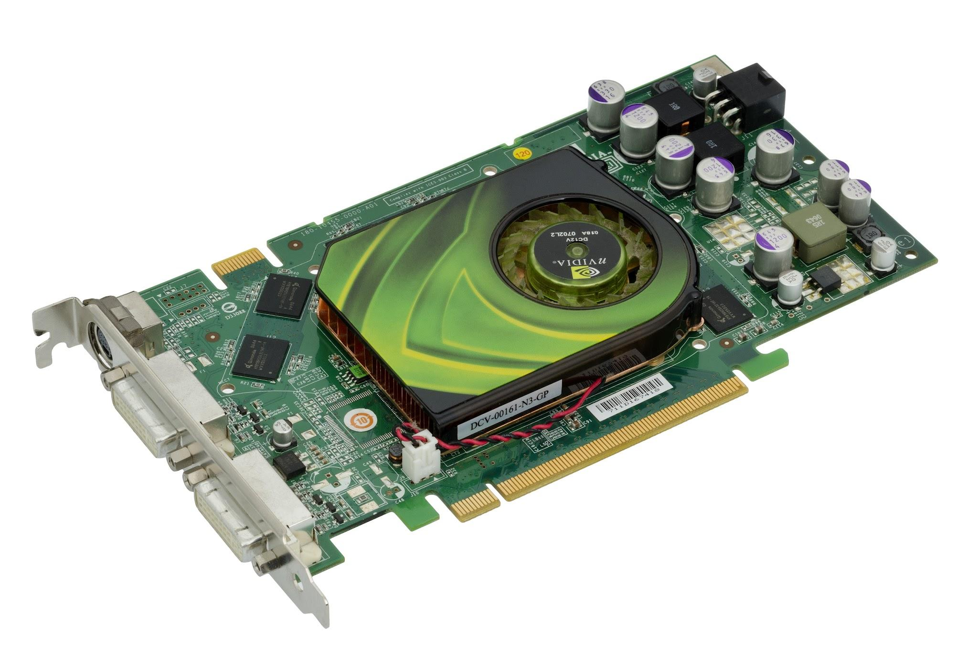

### **8. Cooling System (Fans & Heatsinks)**

Cooling systems dissipate heat generated by the CPU, GPU, and other components. Proper cooling prevents overheating and maintains system stability. Air cooling solutions include case fans, CPU heatsinks, and thermal paste, while liquid cooling systems use radiators and coolant to dissipate heat more efficiently. Proper airflow within the case is crucial for maintaining low temperatures. Overclocking requires enhanced cooling solutions to prevent damage to components. High-end gaming PCs and workstations often include custom liquid cooling loops to handle extreme workloads while maintaining silence and efficiency.

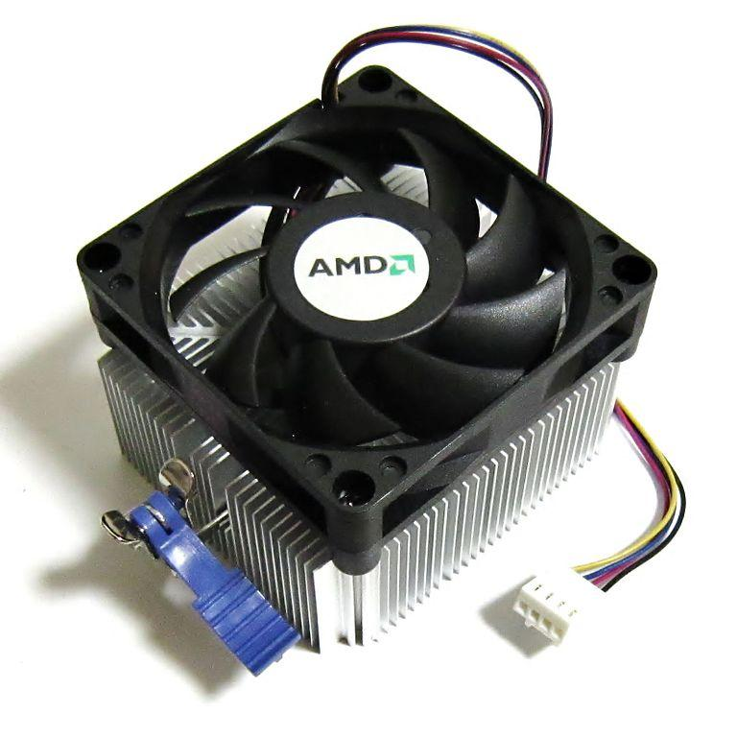

### **9. Optical Drive (CD/DVD/Blu-ray)**

Optical drives allow reading and writing of CDs, DVDs, and Blu-ray discs. While less common today, they are still used for software installation and media playback. Blu-ray drives offer higher storage capacity for high-definition media. Optical drives are gradually being replaced by USB drives and cloud storage. However, they remain relevant for legacy systems and professional applications requiring physical media.

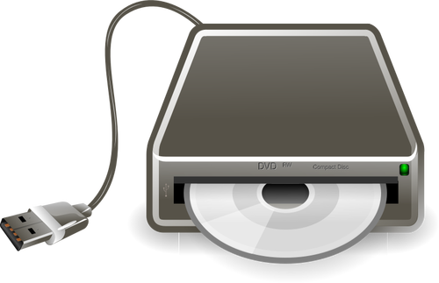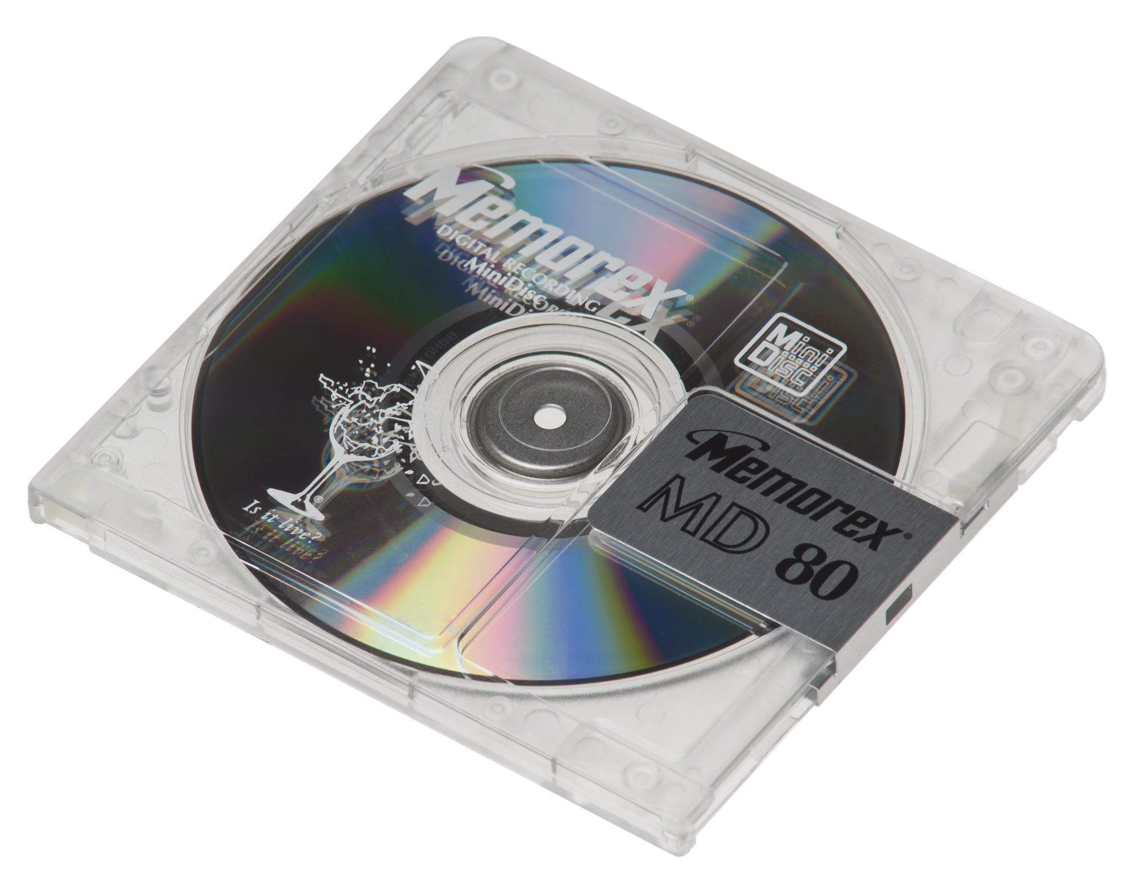

### **10. Network Interface Card (NIC)**

NICs enable computers to connect to networks via Ethernet or Wi-Fi. They are essential for internet access and local network communication. Wired NICs provide stable connections, while wireless NICs offer convenience. Modern NICs support high-speed internet connections and advanced security features.

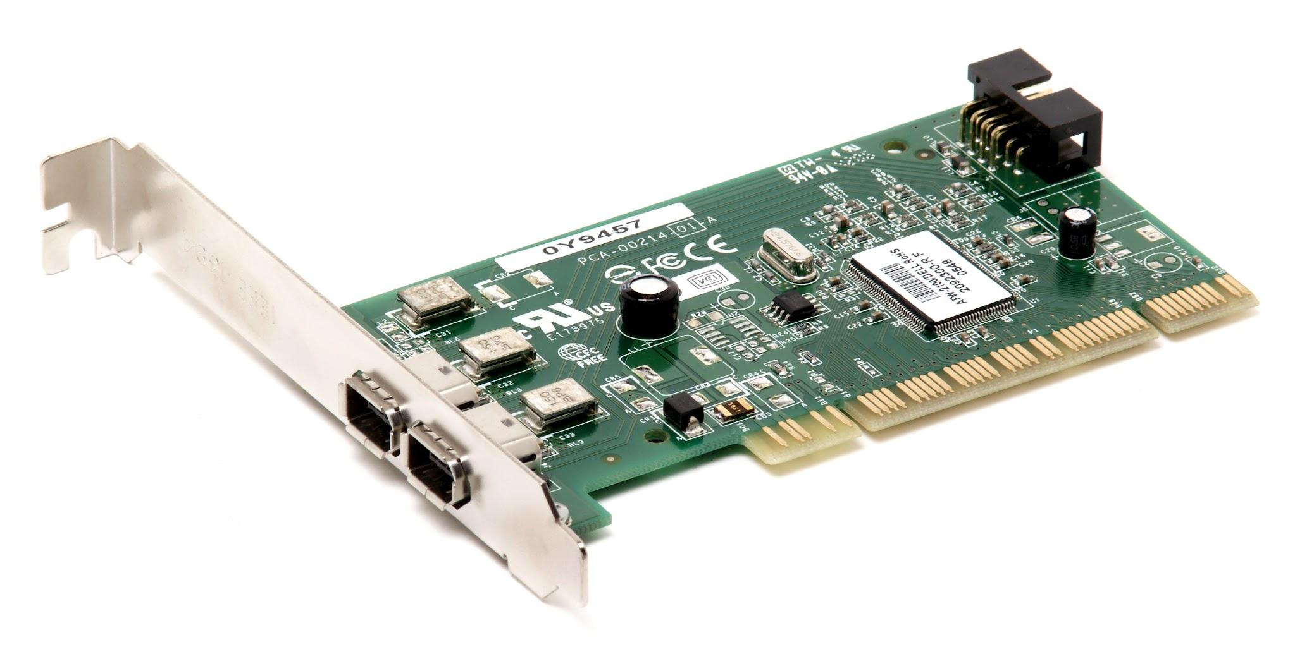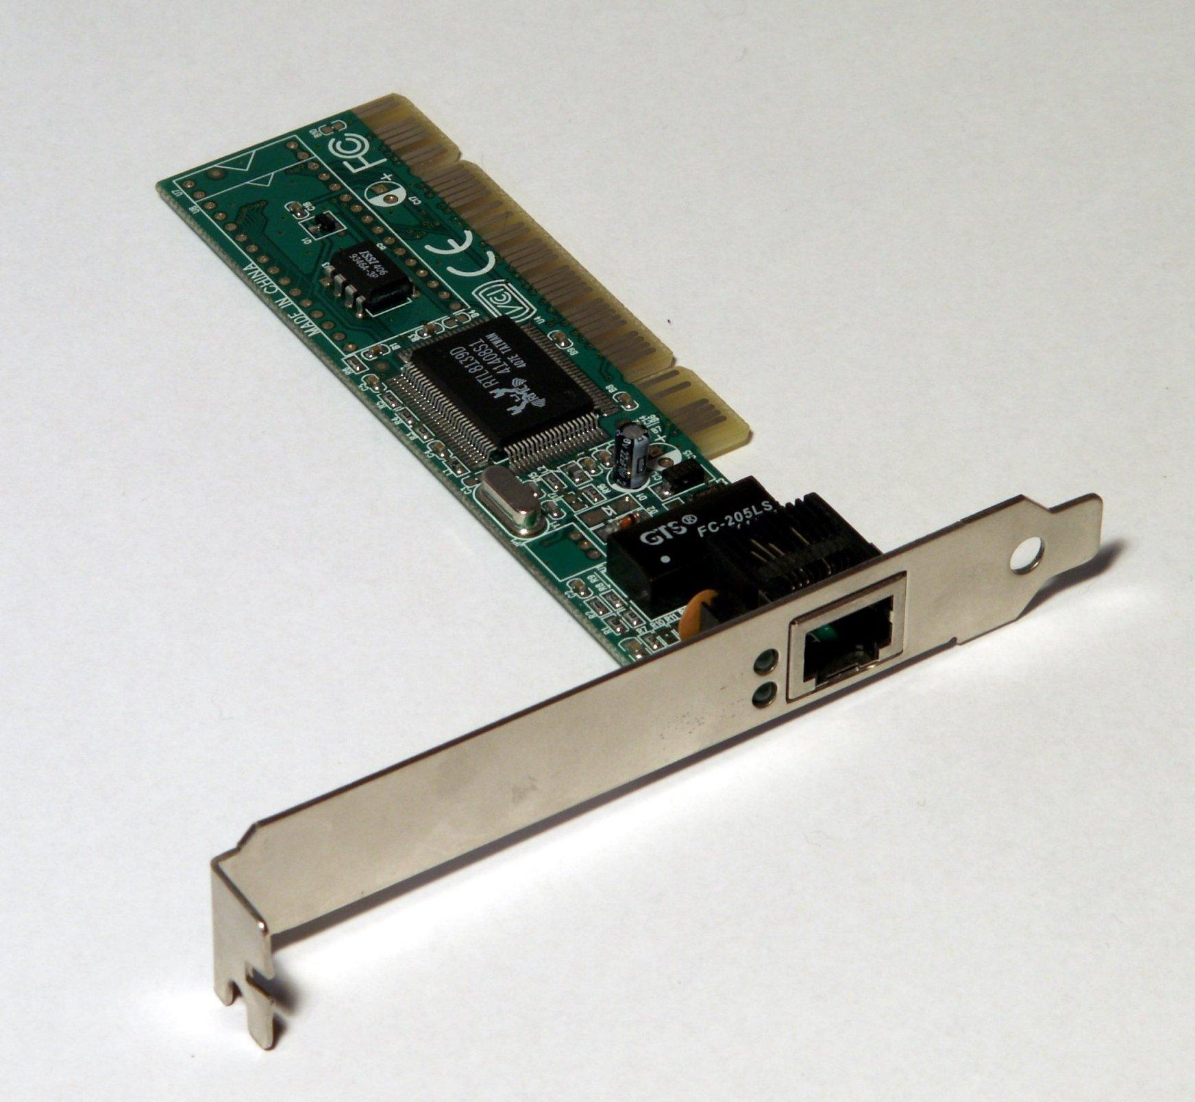

### **11. Sound Card**

Sound cards enhance audio output and input quality. While most motherboards include integrated sound, dedicated sound cards offer improved performance for audiophiles and professionals. They include features such as surround sound, noise cancellation, and advanced audio processing.

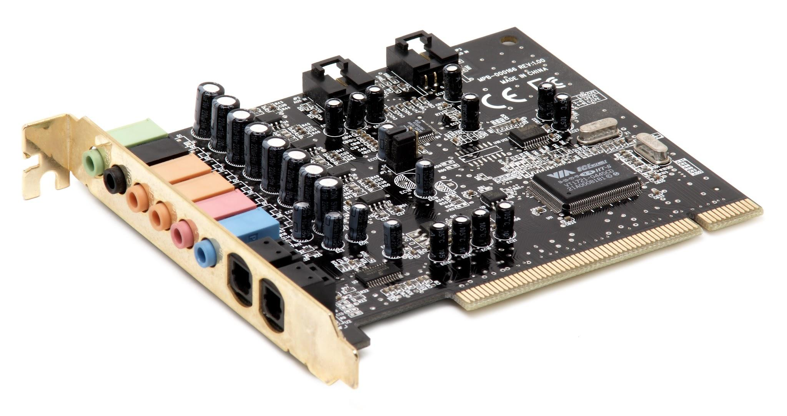

### **12. Input Devices (Keyboard & Mouse)**

Keyboards and mice are primary input devices. Mechanical keyboards and gaming mice provide enhanced functionality for specific user needs. Wireless options improve flexibility, while ergonomic designs enhance comfort during prolonged use.

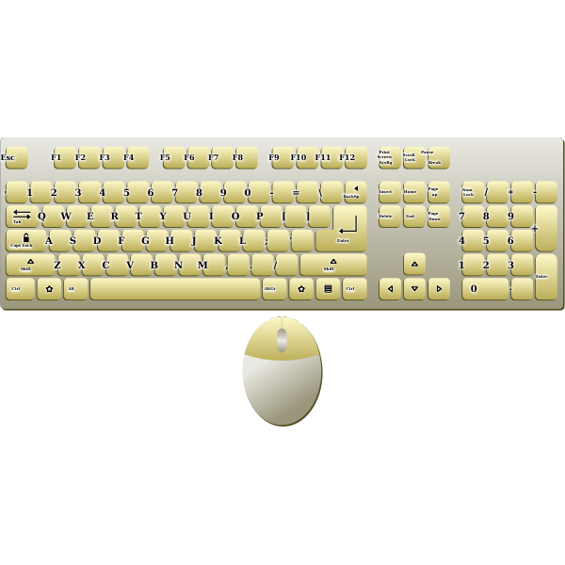

### **13. Output Devices (Monitor & Speakers)**

Monitors display visual output, while speakers provide audio output. High-resolution monitors and surround sound speakers improve user experience. Monitors come in different refresh rates and panel types, while speakers vary in sound quality and connectivity.

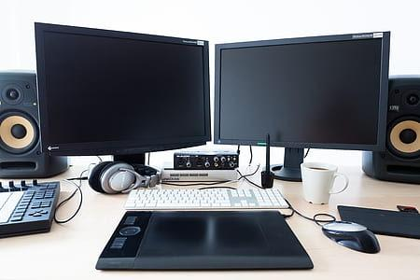

**14. Expansion Cards**

Expansion cards add functionality to a computer, such as additional USB ports, sound enhancements, or advanced networking capabilities. They connect via PCIe slots and enhance system versatility.

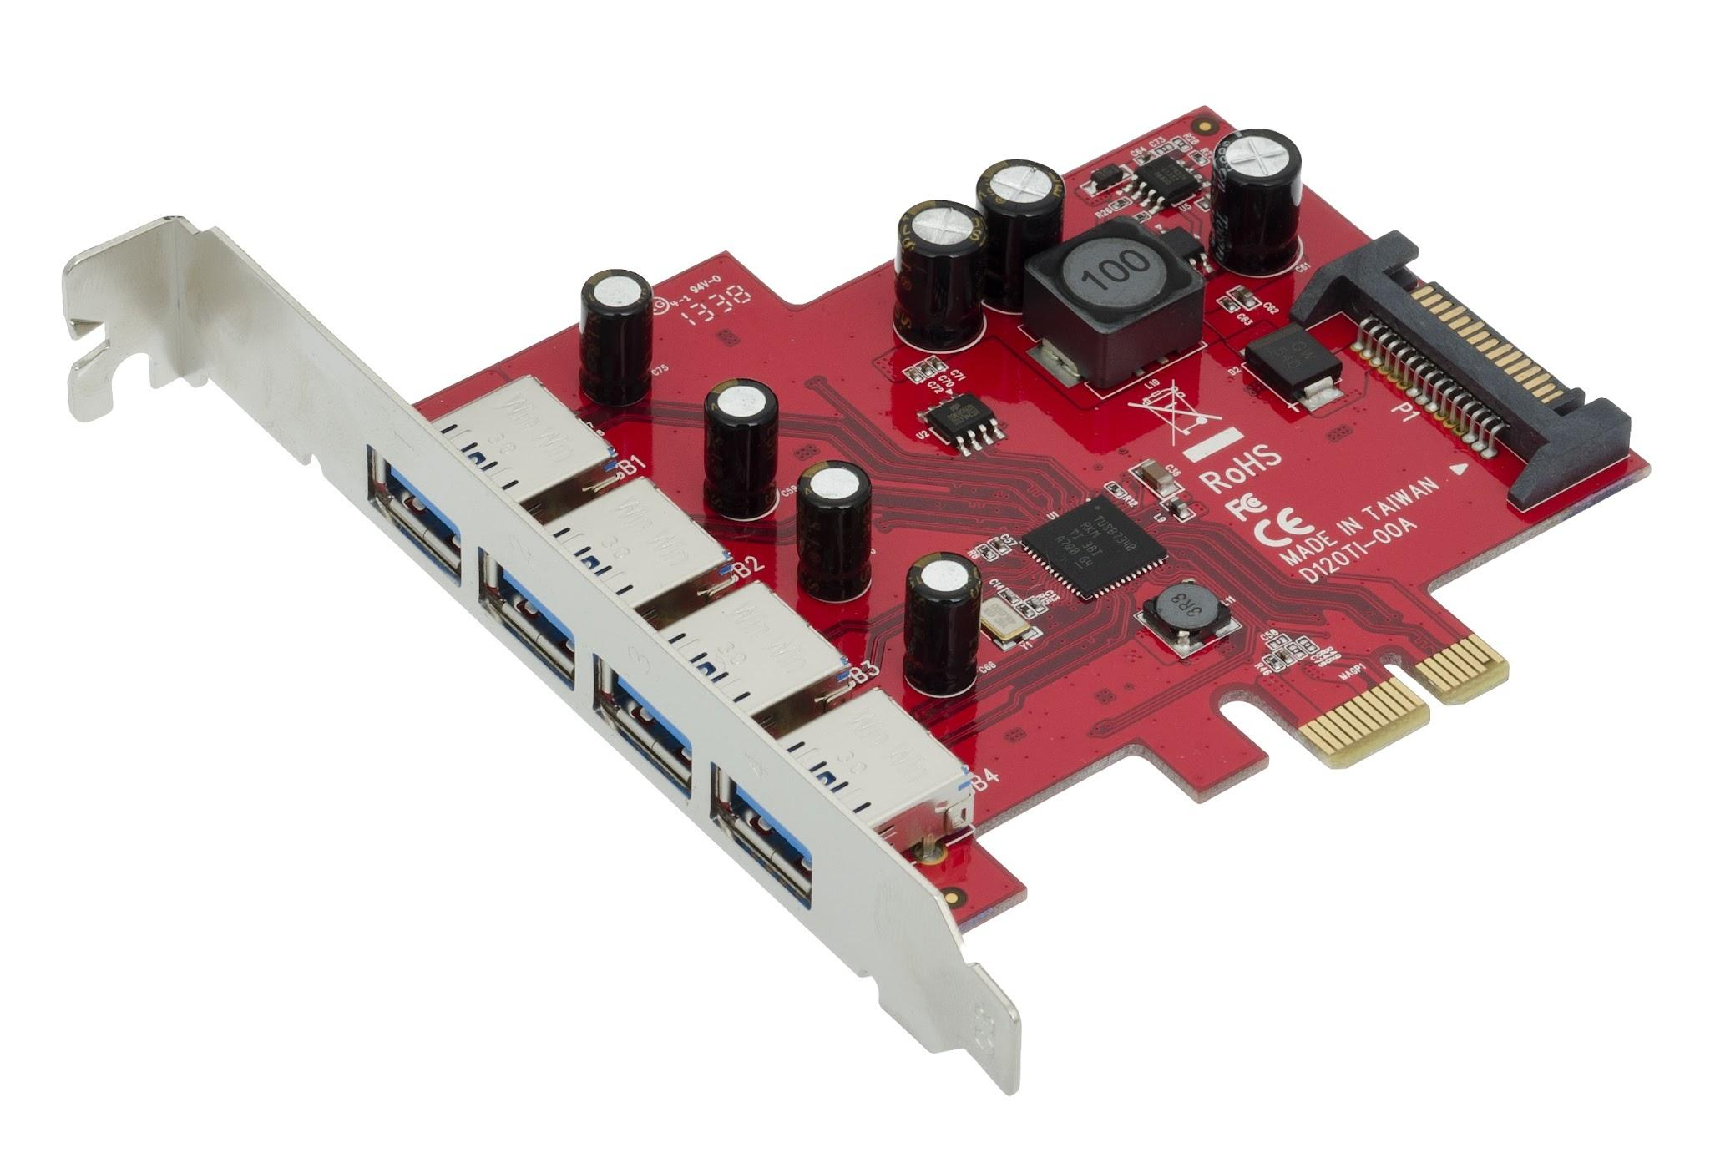

### **15. Peripheral Devices (Printers, Scanners, External Storage)**

Peripherals extend the capabilities of a computer. External storage devices offer backup solutions, while printers and scanners facilitate document handling. Modern peripherals include wireless and cloud-enabled options for enhanced convenience.

|  |
| --- |

